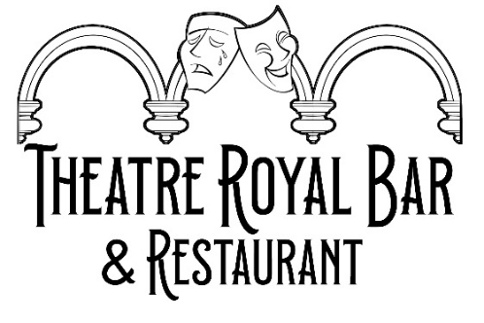
Desserts
Sticky Toffee Pudding toffee sauce & vanilla ice cream £7.50
Cheesecake vanilla ice cream £7.50
Passion Fruit Sorbet fresh fruit garnish £6.50
Vanilla Ice Cream wafer, chocolate sauce £5.50
Cheese Board Brie, Applewood Cheddar, Blue Stilton
Apple & real ale chutney, fresh fruit, oatcakes £12

Digestif
Baileys £4.80 Crem De Menthe £3.70
Cockburn’s Port £4.20 Harveys Solera Sherry £4.20
Frangelico £3.90 Limoncello £4
Hennessy £4.20 Martell VS £4.20
Glayva £3.90 Drambuie £4

Hot Drinks

Irish Cream Coffee £7
Scottish Coffee (Scottish Whisky & cream) £8
Irish Coffee (Irish Whiskey & cream) £8
Hot Toddy (Scottish Whisky, honey, lemon & cloves) £6
Hot Port (Port, honey, orange & cloves) £5

Coffee & Tea

Double Espresso £2.50 Breakfast Tea £2.75
Americano £3.10 Decaf Breakfast Tea £2.75
Latte £3.60 Fruit & Herbal Tea £3.00
Cappuccino £3.60 (please ask for options)
Flat White £3.40
Hot Chocolate £4.00

Add Syrup: Hazelnut / Vanilla / Salted Caramel £0.60
Oat Milk Substitute £0.55

