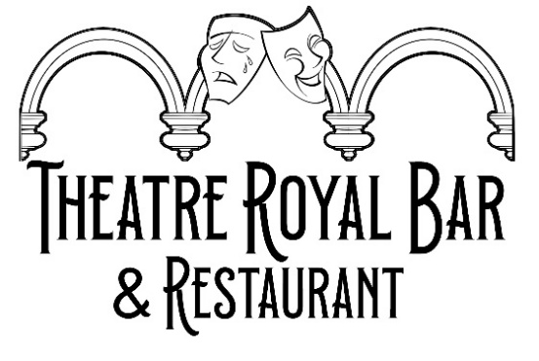
Small plates
Haggis Bon Bons apple & parsnip puree, pickled radish & whisky mayo £7.50
Thai Coconut Chilli Chicken Skewers £7.50
Crab & Shrimp Cakes rocket salad, Remoulade sauce £7.95
Potato & Orkney Cheddar Croquettes (V) tomato chutney, parmesan £6.95
Seasonal Soup (V) sourdough bread & butter £5.95
Spiced Hummus (V) roasted peppers, olives, garlic flatbread £7.95
Halloumi Fries (V) chilli jam £6.50
Campagnola Marinated Olives (V) £5.50

Mains
Steak & Ale Pie mash potatoes, steamed vegetables, puff pastry topping £19
Pan Fried Fillet of Sea Bass crushed potatoes, roasted cherry tomatoes & salsa verde £17.95
Lamb Chops sweet potato mash, grilled asparagus & chimichurri £23
Balmoral Chicken stuffed with haggis & wrapped in streaky bacon, mash potatoes, rainbow baby carrots,
Arran mustard & whisky sauce £21.95
Gilmour Butchers 10oz Rump Steak chips, onion rings, rocket salad & peppercorn sauce £24.95
Chicken Caesar Salad cos lettuce, boiled egg, crispy bacon, croutons, parmesan shavings £15.95
Roasted Sweet Potato & Halloumi Salad (V) mixed salad, pomegranate seeds, cherry tomatoes, cucumber,
red onions, honey & mustard dressing £15.95

Asparagus & Garden Pea Risotto (V) parmesan shavings, garlic flatbread £15.95
Fillet of Scottish Haddock (breaded or battered) chips, garden peas, homemade tartar sauce £18.95
Half fillet £14.50

Sunday Roast- every Sunday
Home Cooked Roast Dinner roasted potatoes, Yorkshire pudding, boiled seasonal vegetables
and gravy £19.95

Steak & Wine Tuesday
Two plates of 10oz Borders Rump Steaks chips, onion rings, rocket salad & peppercorn sauce
With bottle of house wine (Shiraz or Chardonnay) for only £55

We apply 10% discretionary service charge to any parties of 4 or more

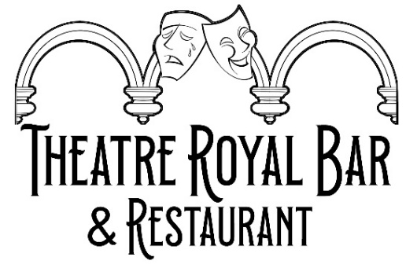
Burgers
Served on toasted sesame Brioche bun with tomato, onion, lettuce & gherkin with side of chips &
red cabbage slaw

Classic Beef two 4oz Borders beef patties, burger sauce £16
Royal With Cheese two 4oz Borders beef patties, smoked Applewood cheddar, burger sauce £17.45
Cajun Chicken Breast grilled pineapple, mozzarella, chilli jam £17.95
Falafel & Spinach (V) spiced chickpea, onion & spinach patty, tomato salsa £13.95

Extra toppings:
Cheddar Cheese £1, Mozzarella £1.50, Blue Cheese £1.50, Streaky Bacon £1.50, Haggis £1,
Fried Egg £1, Jalapenos £1

Snacks To Share
Cheese Board Brie, Applewood Cheddar, Blue Stilton, oatcakes, apple & ale chutney, fresh fruit (V) £13
Nachos tortilla chips, cheese, sour cream, guacamole, tomato salsa & jalapeños (V) £12
Cajun Chicken Nachos £13.50
Loaded Chips choose from:

Haggis, cheddar cheese, mustard & whisky sauce £10
Pulled pork, cheddar cheese & bbq sauce £10

Side dishes
Chips £4
Cheesy Chips £5
Onion Rings £4
Steamed Vegetables £3.50
Mixed Salad Leaves house dressing £3
Rocket Salad cherry tomatoes, parmesan, balsamic £4.50
Sourdough Bread & Butter £2
Red Cabbage Slaw £1.50

Due to the nature of our cooking and size of our kitchen we cannot guarantee that any menu item is 100% free from allergenic substances. Please make sure your server is aware of any allergies when ordering so that we can give you a copy of our allergen list. This highlights the 14 main allergens in each of our dishes which will help you make an informed choice when selecting your meal.

We apply 10% discretionary service charge to any parties of 4 or more

